PIZZA SALES SQL QUERIES

A. KPI’S
1. Total Revenue:
SELECT SUM(total_price) AS Total_Revenue from pizza_sales_data;

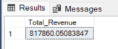
2. Average Order Value:
SELECT SUM(total_price) / COUNT(DISTINCT order_id) AS Avg_Order_Value from pizza_sales_data;
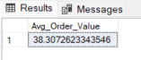
3.Total Pizzas Sold:
SELECT SUM(quantity) AS Total_Pizza_Sold from pizza_sales_data;
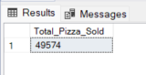
4.Total Orders:
SELECT COUNT(DISTINCT order_id) AS Total_Orders from pizza_sales_data;
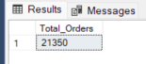
5.Average Pizzas Per Order:
SELECT CAST(CAST(SUM(quantity) AS DECIMAL(10,2)) /
CAST(COUNT( DISTINCT order_id)AS DECIMAL(10,2)) AS DECIMAL(10,2)) AS Avg_Pizzas_per_Order from pizza_sales_data;
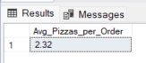
B. DAILY TREND FOR TOTAL ORDERS:
SELECT DATENAME(DW,order_date) as Order_day,
COUNT(DISTINCT order_id) AS Total_orders
from pizza_sales_data
GROUP BY DATENAME(DW,order_date)
ORDER BY Total_orders DESC;

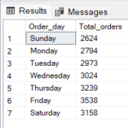
C.MONTHLY TREND FOR TOTAL ORDERS:
SELECT DATENAME(MONTH,order_date) AS Month_Name,
COUNT(DISTINCT order_id) AS Total_Orders
FROM pizza_sales_data
GROUP BY DATENAME(MONTH,order_date)
ORDER BY Total_Orders DESC;
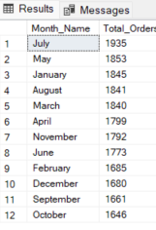
D.PERCENTAGE OF SALES BY PIZZA CATEGORY:
SELECT pizza_category,SUM(total_price) AS Total_Sales, SUM(total_price) *100/
(SELECT SUM(total_price) from pizza_sales_data) AS PCT
FROM pizza_sales_data
GROUP BY pizza_category;
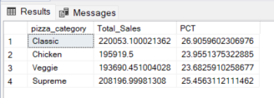
E.PERCENTAGE OF SALES BY PIZZA SIZE:
SELECT pizza_size,
CAST(SUM(total_price) AS DECIMAL(10,2)) AS Total_Sales,
CAST(SUM(total_price) *100/
(SELECT SUM(total_price) from pizza_sales_data) AS DECIMAL(10,2)) AS PCT
FROM pizza_sales_data
GROUP BY pizza_size
ORDER BY PCT DESC;
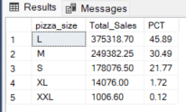
F.TOTAL PIZZAS SOLD BY PIZZAS CATEGORY:
SELECT pizza_category,
SUM(quantity) AS Total_Pizza_Quantity
from pizza_sales_data
GROUP BY pizza_category
ORDER BY Total_Pizza_Quantity DESC;
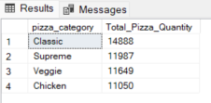
G.TOP 5 PIZZAS BY REVENUE:
SELECT TOP 5 pizza_name,
SUM(total_price) AS Total_Revenue
FROM pizza_sales_data
GROUP BY pizza_name
ORDER BY Total_Revenue DESC;
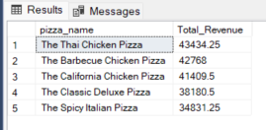
H.BOTTOM 5 PIZZAS BY REVENUE:
SELECT TOP 5 pizza_name,
SUM(total_price) AS Total_Revenue
FROM pizza_sales_data
GROUP BY pizza_name
ORDER BY Total_Revenue ASC;
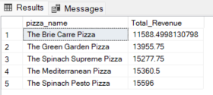
I.TOP 5 PIZZAS BY QUANTITY:
SELECT TOP 5 pizza_name,
SUM(quantity) AS Total_Quantity
FROM pizza_sales_data
GROUP BY pizza_name
ORDER BY Total_Quantity DESC;

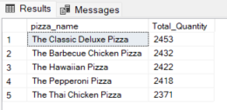

J.BOTTOM 5 PIZZAS BY QUANTITY:
SELECT TOP 5 pizza_name,
SUM(quantity) AS Total_Quantity
FROM pizza_sales_data
GROUP BY pizza_name
ORDER BY Total_Quantity ASC;
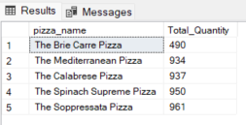
K.TOP 5 PIZZAS BY TOTAL ORDERS:
SELECT TOP 5 pizza_name,
COUNT(DISTINCT order_id) AS Total_Orders
FROM pizza_sales_data
GROUP BY pizza_name
ORDER BY Total_Orders DESC;
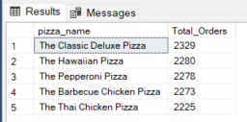
L.BOTTOM 5 PIZZAS BY TOTAL ORDERS:
SELECT TOP 5 pizza_name,
COUNT(DISTINCT order_id) AS Total_Orders
FROM pizza_sales_data
GROUP BY pizza_name
ORDER BY Total_Orders ASC;
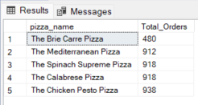

NOTES:
If you want to apply the Month, Quarter, Week filters to the above queries you can use WHERE clause. Follow some of below examples

SELECT DATENAME(DW, order_date) AS order_day,
COUNT(DISTINCT order_id) AS total_orders
FROM pizza_sales_data
WHERE MONTH(order_date) = 1
GROUP BY DATENAME(DW, order_date);

“Here MONTH(order_date) = 1 indicates that the output is for the month of January.
MONTH(order_date) = 4 indicates output for Month of April.”

SELECT DATENAME(DW, order_date) AS order_day,
COUNT(DISTINCT order_id) AS total_orders
FROM pizza_sales_data
WHERE DATEPART(QUARTER, order_date) = 1
GROUP BY DATENAME(DW, order_date);

“Here DATEPART(QUARTER, order_date) = 1 indicates that the output is for the Quarter 1.
DATEPART(QUARTER, order_date) = 3 indicates output for Quarter 3.”

